Parents’ Handbook

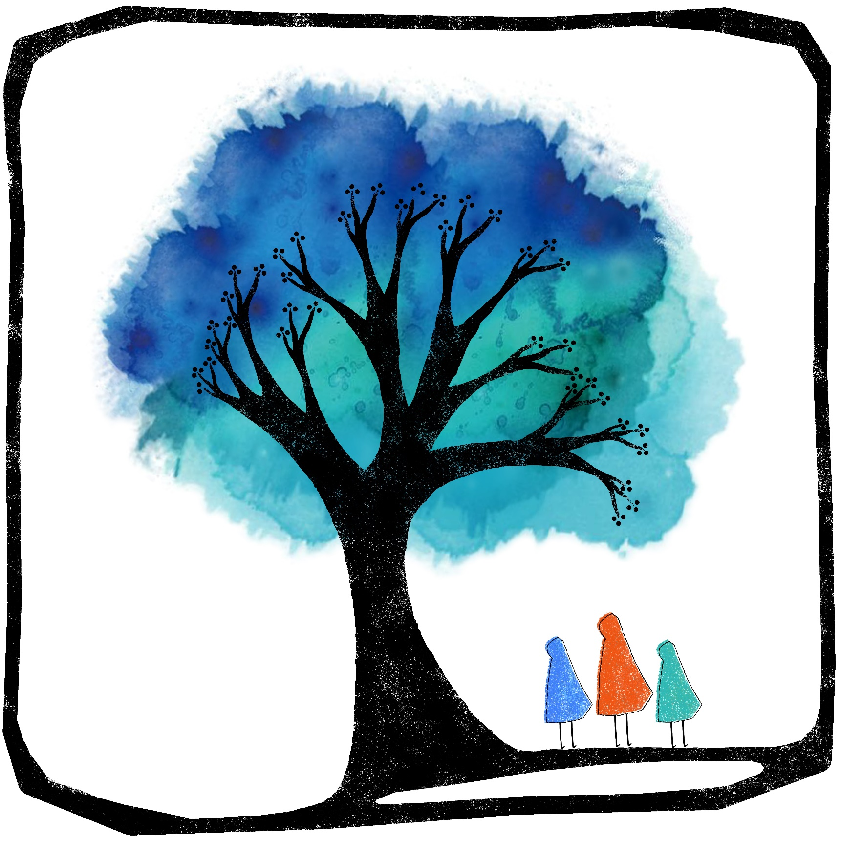
Welcome

Introduction
You are warmly welcomed to Free Spirits Kindergarten: a unique, alternative, play-based learning environment offering childcare for children aged 3-7. We strive to provide natural learning experiences for children that will respect them as individuals, cater for all aspects of development and allow learning at each child's pace. Children will learn through play, exploration, discovery and imaginative experiences, with plenty of time spent outdoors, in an aesthetically pleasing, ergonomic environment.

The Manager
Gemma Gammon: 07753 620246 freespiritseducation@outlook.com
www.freespiritseducation.com www.facebook.com/freespiritseducationchildcare
Gemma’s qualifications include B. Ed. (Hons) Primary Education degree, Diploma in Steiner Waldorf Education (ongoing), Certificate of Higher Education in Business Management (1 year), Paediatric First Aid, Designated Safeguarding Lead and DBS certified. Teaching and childcare experience of 20 years spans children aged 0-18 including working with children with Special Educational Needs 1:1, in SEN centres, in classroom environments and as a private tutor. Gemma is also a mother of two young children.

Opening Hours
We operate during Hampshire school Term Times, Monday to Friday, 8am-5pm. Our core day runs 10am-2:30pm, and additional hours are available to book at half-hourly intervals. There is no minimum attendance requirement. Childcare and private tutoring is available on request during school holidays.
Finding Us
Address: Free Spirits Cabin, Norman Court, West Tytherley, Salisbury SP5 1NH.
Entry to the estate is only via the entrance road shown on the map.
To find the car park, go past the manor house all the way to the woodland at the back. Backtrack to Free Spirits Cabin which is opposite Blake Hall (sports hall), next to the tennis courts.
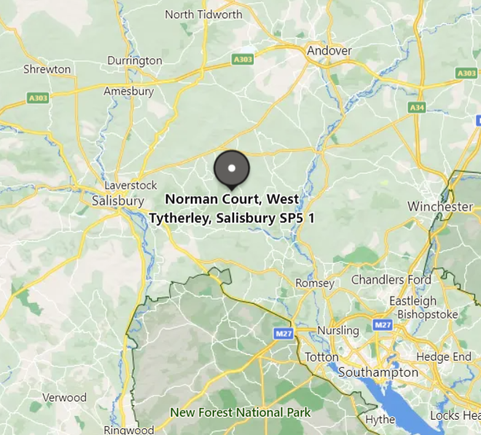
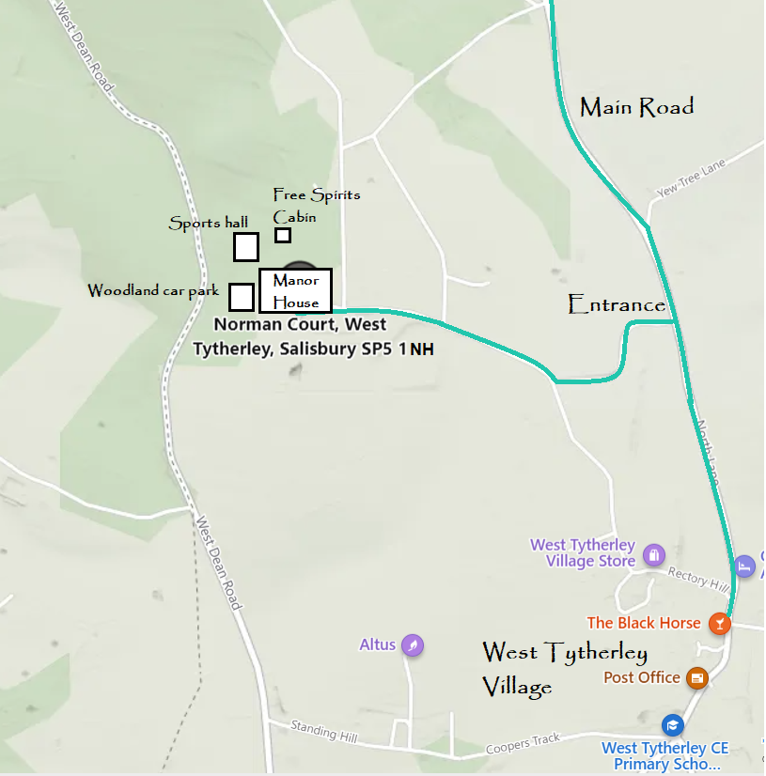
NH
Registration
Parents must complete a Registration & Permissions Form for each child before attending their first session. A one-off membership fee of £50 per family is due after your child attends three childcare sessions. This fee covers the admin, insurance, Ofsted and legal costs associated with providing regulated childcare.
Account Name: Free Spirits Education CIC. Bank: Starling.
AC: 26924640 SC: 60-83-71

Fees
Our core day runs 10am-2:30pm which costs £30 per day, and additional hours cost £7, available to book at half-hourly intervals. Children aged 3 and 4 are entitled to 15 or 30 hours per week of Government-funded childcare which can be used at Free Spirits, with additional costs (e.g. food, specialist activities) being met by the parents. We can apply for this funding on your behalf and just need your signature on the paper form. Funding is valid until the term after your child’s 5th birthday. ‘Earlybird’ discounts are often available for parents who book in advance by a particular date for each forthcoming term. Subscribers to the e-newsletter also benefit from occasional discount codes.

Booking
Sessions must be booked online at least 24 hours in advance, and preferably before the beginning of the term. All bookings are managed through Fienta and payment is taken at the time of booking. Booking links can be found at www.freespiritseducation.com/bookingforms.

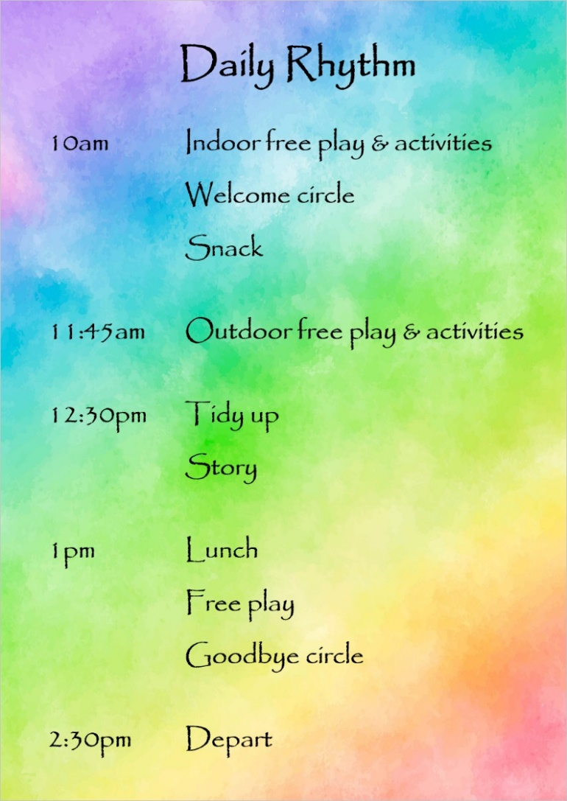
Structure of the Day
We follow a loose rhythm that is subject to change depending on the weather, group’s mood etc.

Please ensure your child has sufficient outdoor clothing, and slippers for indoors if required (outdoor shoes must be removed before entering the cabin).
Ethos
Free Spirits is a unique combination of Steiner Waldorf, Montessori and Forest School philosophies, encompassing the common aspects of all three of these alternative education approaches.
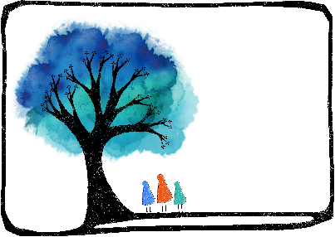
Alternative Education Approaches
Free Spirits

Steiner Waldorf Pedagogy
Steiner Waldorf education aims to provide an unhurried and creative learning environment in harmony with different phases of a child’s development. It strives to develop pupils’ intellectual, artistic and practical skills in an integrated and holistic manner. Children should have joyful childhoods and do not start formal learning until at least at 6.

Montessori Pedagogy
Montessori education is based on self-directed activity, hands-on learning and collaborative play. It should develop natural interests and activities rather than use formal teaching methods.

Forest School Pedagogy
Forest School is a child-centred learning process that offers opportunities for holistic growth through regular sessions in natural environments. It involves play, exploration and supported risk-taking, and develops confidence and self-esteem through learner-inspired, hands-on experiences in a natural setting.
​
Free Spirits Rules
- Please remove outdoor shoes when entering the cabin.
- Please refrain from using mobiles phones, ensuring you remain fully present in your child’s company.
- Please do not take photos of other children without their parents’ permission.
- Please do not offer personal care (dressing, toileting, eating) to children other than your own.
- Please do not smoke or vape anywhere on the premises.
- Please respect and help to maintain the premises.
- Please intervene in any disputes between children fairly and respectfully, encouraging the children involved to problem-solve together rather than dictating a solution.
- Adults should behave in a manner that is calm, gentle, polite and worthy of imitation.
- Children are expected to treat everything on the premises with responsibility and respect.
- Children are expected to help with the daily running of the day, such preparing food, washing up, tidying and cleaning the cabin.

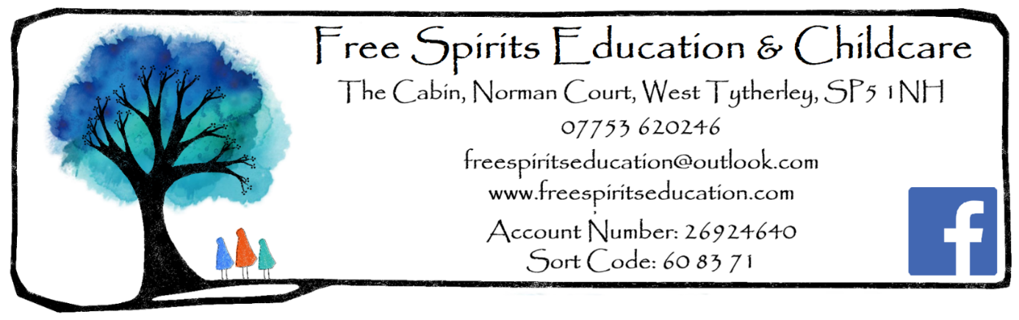
The remainder of this Parents’ Handbook can be found on the website.

Surrounding Area
​We are situated in the heart of the countryside on the Wiltshire/ Hampshire border in the picturesque village of West Tytherley. Our base is a wooden cabin with its own private garden within the grounds of Grade II listed manor house Norman Court, which benefits from 42 acres of fields and woodland, as well as infrastructure that was in place when the manor house itself was formerly used as a school.

Policies
Free Spirits Education CIC has the following policies which explain what we believe and how we will implement these beliefs:
- Child Conduct
- Curriculum
- Ethos
- Health and Safety
- Safeguarding and Child Protection
- Staff

Parents may wish to familiarise themselves with these policies and procedures. They are found on the centre website www.freespiritseducation.com and are also available on request by email.

Free Spirits Education believes in working in close partnership between parents. In order to allow each child to engage fully with the education we offer, we ask parents to:
- Complete the Registration & Permissions Form before the child’s first attendance
- Provide healthy rhythms for the child: a healthy diet, ensure adequate sleep, and limit access to screen devices
- Support their child in adhering to the Child Conduct Policy
- Provide suitable clothing and equipment for the child
- Show an active interest in the child’s education
- Attend meetings as requested
- Discuss any behavioural concerns with the class teacher promptly
- Inform the centre of any changes in circumstances that may affect their child’s behaviour
- Seek help with issues around parenting and other relationships within the home, particularly if they are likely to affect the child’s mental wellbeing
- Not smoke or vape on site
- Not use mobile phones or cameras on site
- Adhere to the agreed drop-off and collection times for your child

We are subject to regular Ofsted checks, and we are obliged to follow the EYFS (Early Years Foundation Stage) Framework for children under 5.

Providers must keep a daily record of the names of children being cared for on the premises, their hours of attendance and the name of each child’s key person. Your child’s key person will be the Manager, Gemma Gammon, unless informed otherwise.

Child Illness
Every child needs to be well enough to cope with the busy activity of the centre. Parents must respect that we are not able to offer a one-to-one ratio for children who are unwell. If the Manager believes that the child is not well enough to cope with the session, it is expected that parents will collect their child if requested to do so. This judgement will take into consideration the welfare of all the children and staff of the setting.

Unwell children should not be brought to the centre, particularly if there is any chance that they might be infectious or if parents do not know the cause of the illness. If staff suspect that a child is ill, parents will be contacted at the very first opportunity. Staff will state their concerns about a child’s health and discuss a suitable plan of action.

Children who become unwell during the day
If children appear unwell during the day – for example, if they have a temperature, sickness, diarrhoea or pain – staff will call the parents and ask them to collect the child.

If the child’s temperature stays worryingly high, then staff may give them Calpol, after first obtaining verbal consent from the parent where possible. This is to reduce the risk of febrile convulsions, particularly for younger children. In extreme cases of emergency, an ambulance will be called and the parent informed.

Administering Medicines
Children may attend the centre needing non-prescribed medicine (e.g. Calpol) to be given during the session only if the Manager feels that it is appropriate for the child to attend the session and receive this medicine.

While it is not the centre’s policy to care for sick children, the Manager will agree to administer medication as part of maintaining their health and well-being or when they are recovering from an illness. Only medication prescribed by a doctor is administered. It must be in-date, bearing the child’s name and prescribed for the current condition. Parents must give prior written permission for the administration of medication, along with clear instructions. A written record of medicine administered must be kept and shared with the parents the same day.

If a child has been prescribed an inhaler or EpiPen, they must be brought in whenever the child attends.

Minimum exclusion periods for the common childhood illnesses published by HPA:

Illness | Exclusion periods
Chicken pox | 5 days after the onset of the rash and last blister has scabbed over (can affect pregnancy if the woman has not already had the infection)
Cold Sores | None (avoid contact with the sores)
Conjunctivitis | None
Diarrhoea and vomiting | 48 hours after last symptoms of vomiting and/or diarrhoea
Glandular fever | None (seek medical advice as this illness can last for several months)
Hand, Foot and Mouth disease | None
Head Lice | None (treatment recommended when live lice seen)
Hepatitis A | Exclude until 7 days after onset of jaundice/symptoms
Hepatitis B and C | None (strict hygiene precautions should be observed if handling bodily fluids)
Impetigo | Until lesions are crusted or healed or 48 hours after starting antibiotic treatment
Influenza | Exclusion until child is feeling well to return
Measles | 4 days after the onset of the rash
Meningitis | Exclusion until recovered
MRSA | None
Mumps | 5 days after the onset of swelling
Ringworm | Can return once treatment has commenced
Rubella (German Measles) | 5 days from onset of rash
Scabies | Can return once treatment has commenced
Scarlet Fever | 24 hours after starting appropriate antibiotics
Slapped Cheek | None
Threadworm | None
Warts and verrucae | None (keep covered)
Whooping cough | 2 days after starting antibiotic treatment, or 21 days from onset of illness if no antibiotic treatment.

Uncollected Child Policy
If parents become aware that they will be delayed in collecting their child, they should contact the Manager immediately on 07753 620246.

Parents are asked to list on the Registration Form who has authorisation to collect their child. If an authorised adult does not collect the child at the expected collection time, the following procedure will be followed:
- 30 minutes will be allowed in case of a minor delay. Staff will check for communications informing the centre of a planned delay.
- After 30 minutes, the parent will be telephoned.
- If the parent is uncontactable, the emergency contacts listed on the Registration Form will be telephoned in turn.
- If the emergency contacts are uncontactable, the authorised adults will be contacted if possible.
- If no-one collects the child after one hour and there is no-one who can be contacted to collect the child, we will contact Hampshire Children’s Services: 0300 555 1384 (Mon-Thu 8:30am-5pm, Fri 8:30am-4:30pm) / Hampshire Children’s Services out-of-hours: 0300 555 1373
- The child will stay at the centre in the care of a member of staff until the child is safely collected either by an authorised adult or by a social worker. Social Care will aim to find the parent or relative. If they are unable to do so, the child will become ‘Looked After’ by the Local Authority.
- Under no circumstances will staff go to look for the parent or take the child home with them.
- A full written report of the incident is to be recorded in the child’s file.

Depending on circumstances, the centre reserves the right to charge parents a late collection fee for the additional hours worked by staff. Parents/carers attending any sessions at the centre are responsible for their own child at all times.

Missing Child Policy
Children’s safety is maintained as the highest priority at all times both on and off premises. Parents/carers attending any sessions at the centre or offsite are responsible for their own child at all times. In the unlikely event of a child going missing, the following procedure will be followed:
- As soon as staff notice that a child is missing, they must inform the Manager.
- The Manager will carry out a thorough search of the immediate vicinity, indoors and out.
- The Manager will alert other adults in the vicinity and enlist their help in searching for the child.
- The Manager will call the police to report the child missing and then call the parent.
- The register will be checked to make sure no other child has also gone astray.
- Doors and gates will be checked to see if there has been a breach of security whereby a child could wander out.
- The Manager will endeavour to find out when and where the child was last seen.
- The incident will be recorded and investigated.

Parents should be aware that Free Spirits Education operates from the main Cabin and has its own private garden. However, we will also from time to time take children to other areas of the Norman Court estate on foot to areas such as the play area and the woods. Permission will be sought in advance for any outings out of the boundary of the Norman Court estate.

Special Educational Needs
As our approach is child-centred and based on children’s needs, developmental stage and emotional state, Free Spirits Education aims to be accessible to all children. The Curriculum at Free Spirits Education is largely based on the Steiner Waldorf Early Years Curriculum, which supports and values the benefits of an unfettered childhood and allows children to be the ‘free spirits’ that they are, rather than seeking to institutionalise them. The children are not rushed or over-stimulated and are allowed space to develop physical coordination and personal, social and cognitive skills.

However, if your child requires a higher level of adult assistance/intervention than we are normally able to provide, we may by negotiation be able to hire additional staff to support your child, the cost of which you will have to meet.

Assessment
Free Spirits Education does not have to conduct the Reception Baseline Assessment as we are a private education centre rather than a maintained school. We do, however, have to complete the Early Years Foundation Stage Profile by 30th June in the academic year in which children turn 5. This Profile simply states whether or not the child has met the 17 Early Learning Goals as detailed in the EYFS. Children will be assessed through observation and collaboration rather than through formal assessment procedures. We believe it is more important and useful to really get to know your child well than to have to rely on contrived assessment methods. If your child transfers to Year 1 in a maintained school, their teacher must be given the Profile report.

Volunteering
Please discuss with the Manager if you would like to volunteer at the centre, and whether your intention is to be there to support your child or if you are volunteering to assist the centre as a whole under the direction of the Manager. Please also suggest how long you would like to volunteer for. Acceptance of volunteers into the setting is at the Manager’s discretion and may not always be required or appropriate. A Volunteer Record Sheet will need to be completed for regular volunteers.

An enhanced DBS certificate is required for anyone aged 16+ to work unsupervised with children. Adults who do not have a DBS certificate must be supervised at all times, and may not provide personal care to children other than their own (including eating, drinking, toileting or dressing). Staff:child ratios will be adhered to at all times as detailed in the EYFS. All staff, volunteers and visitors will have their identity checked on arrival.

Concerns and Complaints
If you have a concern regarding Free Spirits Education, please discuss it with the Manager in the first instance. We will take all concerns seriously and make every effort to resolve them.

If you would like to make a formal complaint, please address this to the Manager in writing. We will keep a written record of any complaints, and their outcome. We are required by Ofsted to investigate written complaints relating to our fulfilment of the EYFS requirements and notify complainants of the outcome of the investigation within 28 days of having received the complaint. The following information will be recorded:
- The name of the person making the complaint
- The Early Years Foundation Stage requirement(s) to which the complaint relates
- The nature of the complaint
- The date and time of the complaint
- Any action taken in response to the complaint
- The outcome of the complaint investigation (e.g. how the centre has improved)
- Details of the information and findings that were given to the complainant, including any action taken
If the complaint cannot be resolved or is of a serious nature, you can contact Ofsted on 0300 1231231.

Whistleblowing
All staff can raise concerns about poor or unsafe practice and potential failures in the school safeguarding regime. If your concern is about the Manager/DSL, contact:
Hampshire County Council’s Local Authority Allegation Designated Officer (LADO):
Phone 01962 876364
Email child.protection@hants.gov.uk
https://www.hants.gov.uk/socialcareandhealth/childrenandfamilies/safeguardingchildren/allegations
If you feel your safeguarding concerns are not being addressed, you can contact the NSPCC whistleblowing advice line:
0800 028 0285 from 08:00 to 20:00, Monday to Friday, or email help@nspcc.org.uk

Contact Information
The Director of Free Spirits Education CIC, centre Manager and Head Teacher is: Gemma Gammon
Telephone: 07753 620246
Centre Address: Free Spirits Education CIC, The Cabin, Norman Court, West Tytherley, SP5 1NH

Application Pack

Welcome to Free Spirits Education & Childcare. Please familiarise yourself with the Centre’s website, Parents’ Handbook and policies to ensure we are the right fit for your family. You are most welcome to come for a free taster day.

If you wish to apply for a childcare place at Free Spirits, please complete the Registration & Permissions forms and pay the £50 Registration Fee to secure your child’s place. This fee covers the admin, insurance, Ofsted and legal costs associated with providing regulated childcare, and is payable per family, not per child. Once your child’s place has been confirmed, you will need to show the Manager your child’s birth certificate and your own ID. (These are Ofsted requirements.) Online session booking and payment is due termly in advance via the link at www.freespiritseducation.com/bookingforms.

We operate during Hampshire school Term Times, Monday to Friday, 8am-5pm. Our core day runs 10am-2:30pm which costs £30 per day, and additional hours cost £7, available to book at half-hourly intervals. There is no minimum attendance requirement. Childcare and private tutoring is available on request during school holidays.

Children aged 3 and 4 are entitled to 15 or 30 hours per week of free childcare which can be used at Free Spirits, with additional costs (e.g. food, specialist activities) being met by the parents.

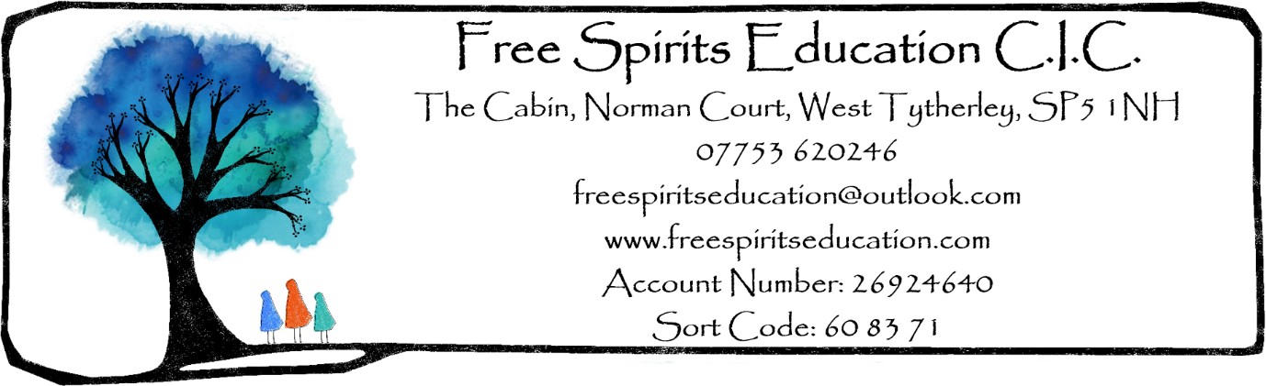

Registration Information

Parent 1 Full Name (primary carer)
Parent 1 Occupation
Parent 2 Full Name (& address if different from child’s)
Parent 2 Occupation
Parent Email Address
Parent Phone Number
Child’s Full Name
Child’s Date of Birth
Address (child’s primary residence)

Allergies, Dietary Requirements, Medical Needs, SEND etc.

Emergency Contact Details (min. 2 names and phone numbers)

Collection Authorisation (list all people who may collect your child)
Is your child involved with Social Services, Paediatrician Services etc?
Type of Parent ID presented:
Child’s birth certificate presented: | Original / photocopy / electronic image

Permissions

- I give permission for my child to have first aid administered by Free Spirits Education staff as and when required: YES/NO

- I give permission for my child to have sun cream applied by Free Spirits Education staff as and when required: YES/NO

- I give permission for my child to be taken to hospital and/or have emergency paramedic treatment as and when required: YES/NO

- I give permission for Free Spirits Education staff to take identifiable photographs/videos of my child for the purposes of record-keeping and use/display within the centre labelled with first names: YES/NO

- I give permission for Free Spirits Education staff to take identifiable photographs/videos of my child for use on company media e.g. the Facebook page, website, which will not bear the children’s name: YES/NO

Please add any relevant information here (even if included on the Registration Form) e.g. relating to allergies, first aid, medical conditions, use of photographs/videos etc:

Signed:_________________________ Relationship to chid:__________________

Print name:_______________________________ Date:_____________________

